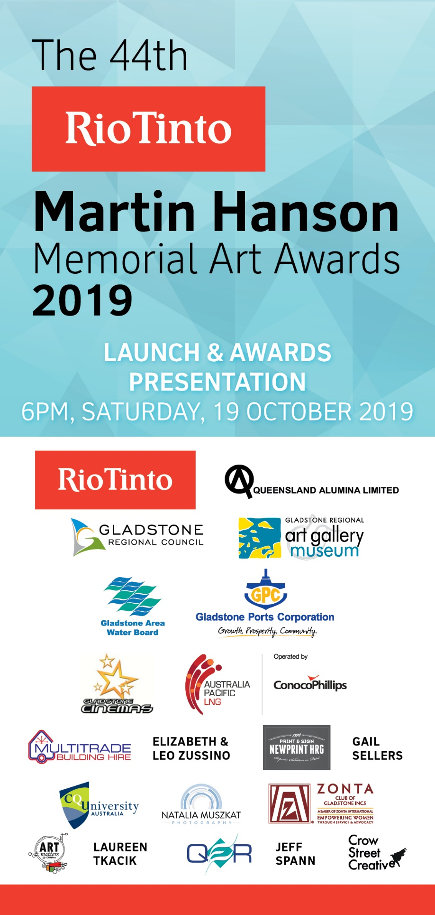
The 44th Rio Tinto
Martin Hanson
Memorial Art Awards
19 October – 5 December 2019

Education Kit & Information

Early Learning to
Year 10

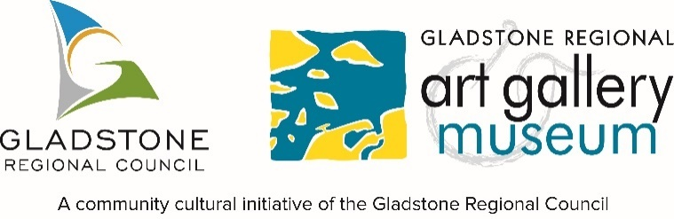

Contents

About the exhibition 3

Program/Curriculum links Early Learning to Year 2 4

Program/Curriculum links Year 3 to 4 7

Program/Curriculum links Year 5 to 6 10

Program/Curriculum links Year 7 to 8 12

Program/Curriculum links Year 9 to 10 15

Contact information & booking form 18

Booking form 19

About the exhibition

In 1974, the Gladstone District Artists Club Annual Art Show was displayed at Anderson’s Auto on the corner of Goondoon and William streets. Two years later, it was renamed the Martin Hanson Memorial Art Awards/Exhibition. Since this first show, the Art Awards have grown and transformed, attracting local, national and even international artists. The Gladstone Regional Art Gallery & Museum has been the custodian of the Awards since 1993.

Works can be submitted under four main categories:
- Easel Paintings: mixed media, acrylic, collage, oil etc. on non-paper-based supports
- Works on Paper: drawing, watercolour, collage, mixed media, print etc. on paper-based supports
- Three Dimensional & Fibre Works: sculpture including fibre, timber, metal, stone, plastics etc., ceramics, textile objects
- Digital Works: photography, moving image, animation, soundscapes etc.

With over 300 works on display every year, this exhibition provides a fantastic end of year opportunity for students to be inspired for the following year. The exhibition promises to be a dynamic display of new work in traditional and contemporary styles, including painting, drawing, collage, photography, moving image, sculpture, fibre work and more!

The Gladstone Regional Art Gallery & Museum welcomes all early learning groups and school groups to the exhibition. The following exhibition kit & information pack contains everything you need to know about the Art Awards and how it links into the Australian Curriculum.

Program/Curriculum links Early Learning to Year 2
Tour length: Approximately 1 hour
Overview of tour & outcomes:
The aim of this tour is to develop an understanding of basic art terminology and to encourage students to develop evaluating artwork skills.

Students will learn the history of the Art Awards before focusing on four works of art – one from each of the four categories. As a group, they will complete a worksheet that introduces basic terminology and evaluation.

Curriculum links:
Curriculum content description | Elaboration | General capabilities
Create and display artworks to communicate ideas to an audience | Talk about ideas such as themes when displaying artworks, for example, at the local gallery or in their classroom | Personal and Social Capability  Critical and Creative Thinking
 | Considering viewpoints – meanings and interpretations: For example – What did this artwork or design make you think about?
Use and experiment with different materials, techniques, technologies and processes to make artworks | Exploring a range of natural and man-made materials and technologies to visually express their experiences, for example, paint, pencils, ink, sand, photography and graphically | Information and Communication Technology (ICT) Capability  Critical and Creative Thinking
Explore ideas, experiences, observations and imagination to create visual artworks and design, including considering ideas in artworks by Aboriginal and Torres Strait Islander artists | Considering viewpoints – forms and elements: For example – what colours were used? What is it made of? How is the colour used, and why is it used in this way? | Critical and Creative Thinking  Intercultural Understanding
 | Identifying and using visual conventions in their artworks after investigating different art, craft and design styles from other cultures and times, for example Aboriginal and Torres Strait Islander Peoples, and Asia
Respond to visual artworks and consider where and why people make visual artworks, starting with visual artworks from Australia, including visual artworks of Aboriginal and Torres Strait Islander Peoples | Identifying how design elements, such as line, shape, colour or texture, are used in the artwork of others | Intercultural Understanding  Critical and Creative Thinking  Literacy  Personal and Social Capability  Aboriginal and Torres Strait Islander Histories and Cultures
 | Describing and interpreting representations in a selection of artworks, for example, considering the subject matter, styles and techniques
Worksheet (Early Learning to Year 2)
Artwork #1
Q1. What type of artwork is this?

Q2. What colours have been used?

Q3. How do these colours make you feel?

Q4. What lines or shapes can you see?

Q5. Do you like the work? Why or Why not?

Artwork #2
Q1. What type of artwork is this?

Q2. What colours have been used?

Q3. How do these colours make you feel?

Q4. What lines or shapes can you see?

Q5. Do you like the work? Why or Why not?
Artwork #3
Q1. What type of artwork is this?

Q2. What colours have been used?

Q3. How do these colours make you feel?

Q4. Can you see any lines or shapes?

Q5. Do you like the work? Why or Why not?

Artwork #4
Q1. What type of artwork is this?

Q2. What colours have been used?

Q3. How do these colours make you feel?

Q4. Can you see any lines or shapes?

Q5. Do you like the work? Why or Why not?

Program/Curriculum links Year 3 & 4
Tour length: Approximately 1 hour
Overview of tour:
The aim of this tour is to further develop an understanding of basic art terminology and to encourage students to refine their ability to evaluate artworks.

Students will learn the history of the Art Awards before focusing on four works of art – one from each of the four categories. As a group, they will complete a worksheet that introduces more advanced terminology and evaluation.

Curriculum links:
Content Description | Elaboration | General capabilities
Explore ideas and artworks from different cultures and times, including artwork by Aboriginal and Torres Strait Islander artists, to use as inspiration for their own representations | Identifying and explaining choices in art making, including forms, styles and visual conventions in their artworks, and influences of other artists on their artworks | Critical and Creative Thinking  Intercultural Understanding  Aboriginal and Torres Strait Islander Histories and Cultures
Use materials, techniques and processes to explore visual conventions when making artworks | Considering viewpoints – societies and cultures: For example – What clues in the artwork tell you where it was made, who made it, and why? | Critical and Creative Thinking
 | Considering viewpoints – materials and technologies: For example – what is the artwork made of? How does the choice of material enhance the audience’s understanding of the artist’s intention?
Present artworks and describe how they have used visual conventions to represent their ideas | Exploring different ways of presenting artworks in different locations, for example, in folios, digitally, in a public space | Literacy  Critical and Creative Thinking  Personal and Social Capability
Identify intended purposes and meanings of artworks using visual arts terminology to compare artworks, starting with visual artworks in Australia including visual artworks of Aboriginal and Torres Strait Islander Peoples | Considering viewpoints – evaluations: For example – Did you enjoy looking at the artwork? Why? Which artwork do you like the most? Explain why you like it. What artworks do you like to make, and why? | Literacy  Critical and Creative Thinking  Intercultural Understanding  Personal and Social Capability  Aboriginal and Torres Strait Islander Histories and Cultures

Worksheet (Year 3 & 4)
Artwork #1
Title of artwork:

Artist:

Materials:

Why do you think the artist chose these materials?

Do you like the work?
Explain why you do or do not like it.

Artwork #2
Title of artwork:

Artist:

Materials:

Why do you think the artist chose these materials?

Do you like the work?
Explain why you do or do not like it.

Artwork #3
Title of artwork:

Artist:

Materials:

Why do you think the artist chose these materials?

Do you like the work?
Explain why you do or do not like it.

Artwork #4
Title of artwork:

Artist:

Materials:

Why do you think the artist chose these materials?

Do you like the work?
Explain why you do or do not like it.

Program/Curriculum links Year 5 & 6
Tour length: Approximately 1 hour
Overview of tour:
The aim of this tour is to more closely analyse the artworks on display. Students will work in a group to complete a worksheet focusing on one artwork.

The tour will start with a history of Art Awards. Students will then be guided through the different exhibition spaces with a select number of artworks highlighted. Students will then work together to complete a worksheet on one artwork.

Curriculum links:
Content Description | Elaboration | General capabilities
Explore ideas and practices used by artists, including practices of Aboriginal and Torres Strait Islander artists, to represent different views, beliefs and opinions | Considering viewpoints – materials and technologies: What is the artwork made of? How does the choice of material enhance the audience’s understanding of the artist’s intention? | Intercultural Understanding  Ethical Understanding  Critical and Creative Thinking Personal and Social Capability
Plan the display of artworks to enhance their meaning for an audience | Considering viewpoints – societies and cultures: For example – What clues in the artwork tell us where it was made, who made it, and why? | Critical and Creative Thinking Personal and Social Capability
 | Reflecting critically on how effectively their ideas or feelings have been expressed in their own artworks, and that of others
Explain how visual arts conventions communicate meaning by comparing artworks from different social, cultural and historical contexts, including Aboriginal and Torres Strait Islander artworks | Considering viewpoints – meanings and interpretations: For example – What is this artwork about? How did the artist represent their subject matter? | Literacy  Personal and Social Capability  Critical and Creative Thinking Intercultural Understanding  Aboriginal and Torres Strait Islander Histories and Cultures
 | Expressing an opinion about the way numerous artists communicate multiple viewpoints through their artwork

Worksheet (Year 5 & 6)
Before looking at the label, what clues in the artwork help to tell you who made it, where it was made, or why it was made?

Title of artwork:

Artist:

Year and place the artwork was made:

Materials:

What is the artwork about? (Subject matter, theme etc?)

Does the choice of materials used effect how you feel about the artwork? How?

Do you like the work?
Explain why you do or do not like it.

Program/Curriculum links Year 7 & 8
Tour length: Approximately 1 hour
Overview of tour:
This tour allows students to work in small groups and select artworks for analysis.

The tour will start with a history of Art Awards. Students will then be guided through the different exhibition spaces with a select number of artworks highlighted. They will then be divided into small groups within one exhibition space and work together to complete a report. Select groups will be asked to share their results.

Curriculum links:
Content Description | Elaboration | General capabilities
Experiment with visual arts conventions and techniques, including exploration of techniques used by Aboriginal and Torres Strait Islander artists, to represent a theme, concept or idea in their artwork | Investigating how different combinations of techniques can represent a theme, concept or idea, for example, applying paint with different tools to create different textures | Critical and Creative Thinking  Intercultural Understanding  Aboriginal and Torres Strait Islander Histories and Cultures
 | Considering viewpoints – psychology: For example – why and how does an artwork make you feel emotional?
 | Observing how artists select and apply different visual arts techniques to represent themes, concepts and ideas and considering how they could use these in their own art making
Develop ways to enhance their intentions as artists through exploration of how artists use materials, techniques, technologies and processes | Considering viewpoints – meanings and interpretations: For example – Can you identify implied meaning from the symbols and codes within the artwork? | Intercultural Understanding  Critical and Creative Thinking  Information and Communication Technology (ICT) Capability
Develop planning skills for artmaking by exploring techniques and processes used by different artists | Considering viewpoints – societies and cultures: For example – How does the context of time and place, culture and ideology influence the look and meaning of art in public spaces? | Critical and Creative Thinking
Analyse how artists use visual conventions in artworks | Visiting and critiquing a physical or virtual exhibition of art, craft or design, and reviewing how artists have used visual conventions in their artworks | Critical and Creative Thinking
 | Presenting an informed opinion about a display of artworks
Identify and connect specific features and purposes of visual artworks from contemporary and past times to explore viewpoints and enrich their artmaking | Analysing how visual arts practices and processes and use of available technologies shape the practices of art, craft and design
Newspaper article (Year 7 & 8)
Title of artwork:
________________________________________________________________________________

Artist:
________________________________________________________________________________

Brief description, subject/theme - What makes this artwork different from other artists’ works?
________________________________________________________________________________________________________________________________________________________________________________________________________________________________________________________________________________________________________________________________________________________________________________________________________________________________________________________________________________________________
________________________________________________________________________________________________________________________________________________________________
Materials/colours:
________________________________________________________________________________________________________________________________________________________________________________________________________________________________________________________________________________________________________________________________
________________________________________________________________________________________________________________________________________________________________
Technique/s:
________________________________________________________________________________________________________________________________________________________________________________________________________________________________________________________________________________________________________________________________
________________________________________________________________________________________________________________________________________________________________

Use your notes to write a short article (100 – 200 words) for a newspaper on your chosen artwork and/or artist. Consider: What made it stand out to you? What important information would you include?
________________________________________________________________________________________________________________________________________________________________________________________________________________________________________________________________________________________________________________________________________________________________________________________________________________
________________________________________________________________________________________________________________________________________________________________________________________________________________________________________________
________________________________________________________________________________________________________________________________________________________________________________________________________________________________________________
________________________________________________________________________________________________________________________________________________________________________________________________________________________________________________
________________________________________________________________________________________________________________________________________________________________________________________________________________________________________________
________________________________________________________________________________________________________________________________________________________________________________________________________________________________________________
________________________________________________________________________________________________________________________________________________________________________________________________________________________________________________
Program/Curriculum links Year 9 & 10
Tour length: Approximately 1 hour
Overview of tour:
This tour allows students to work in small groups and select artworks for a closer analysis.

The tour will start with a history of Art Awards. Students will then be guided through the different exhibition spaces with a select number of artworks highlighted.

There are two options for the end of tour activity.

Students can either work independently or in small groups. They will choose two artworks with the same or similar themes and compare them critically, focusing on the ‘points of comparison’ outlined in the table.

Or, students can choose a theme and style of artwork and make their own artwork or sketch in the gallery space.

Curriculum links:
Content Description | Elaboration | General capabilities
Present ideas for displaying artworks and evaluate the displays of artworks | Visiting galleries, art museums and public art displays, in formal and informal settings, to research the role of the curator and elements of a good display/exhibition | Critical and Creative Thinking
Analyse a range of visual artworks from contemporary and past times to explore differing viewpoints and enrich their visual artmaking, starting with Australian artworks, including those of Aboriginal and Torres Strait Islander Peoples | Considering viewpoints – critical theories: For example – Do you agree with the artist’s point of view? Give reasons for your view | Intercultural Understanding  Literacy  Critical and Creative Thinking  Personal and Social Capability
 | Considering the responsibilities of visual art practitioners when making commentaries about social, environmental and sustainability issues
 | Identifying how visual arts professionals embed their values and beliefs, and how audiences React and interpret the meaning and intent of their artworks differently

Compare and contrast two artworks (Year 9 & 10)
Points of comparison | Artwork 1 | Artwork 2
Theme - the meaning of the work, e.g. about drought, life, society, human nature
Title of artwork
Artist name
Subject matter: the main focus of the artwork (there may be a clue in the title of the work)
Composition e.g. still life, landscape, portrait, post-internet
Techniques and Media (materials) e.g. traditional brush and paint through to less traditional methods and materials including spray paint, collage, weaving, assemblage and digital printing processes.
Style e.g. abstract, realist, political, narrative, figurative and minimalist artworks
Explain how well you feel that the artist has conveyed their message to the audience?

If you were to create an artwork expressing your thoughts or feelings on this theme, which colours, materials, techniques and subject matter would you choose, and why?
________________________________________________________________________________________________________________________________________________________________________________________________________________________________________________________________________________________________________________________________________________________________________________________________________________
________________________________________________________________________________________________________________________________________________________________________________________________________________________________________________
________________________________________________________________________________________________________________________________________________________________________________________________________________________________________________________________________________________________________________________________________________________________________________________________________________________________________________________________________________________________________________________________________________________________________________________________________________________________________________________________
Contact information & booking form

To book a tour please phone (07) 4976 6766 and speak to the Exhibitions and Education Officer about your proposed visit.
Discuss the date, time, student numbers and what type of visit you are interested in.
Fill in the Group Booking Form with the proposed date and details discussed.

Email the Group Booking Form back to the Education Officer and wait for a confirmation email.

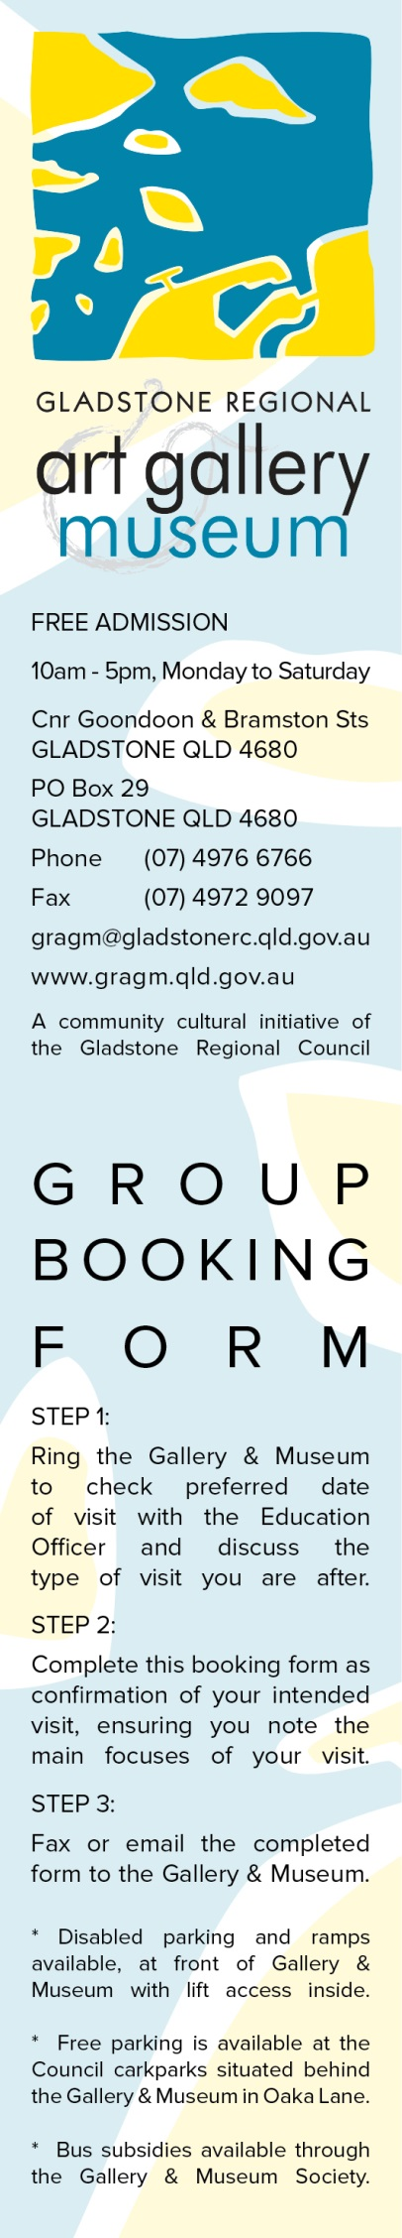
PLEASE FILL OUT THE FOLLOWING GROUP BOOKING FORM
* Required fields

* Name of company/school/group:
________
* Coordinator/teacher's name:
* Address:

* Phone:
Fax: ________
* Email address:
Website:
* Requested visit date: day _____ /_____ /_______
* Arrival time: am pm
* Departure time: am pm
* Number of visitors in group:
* Number of chaperones with group:
* Year level or age of visitors:
* Any disabilities or special needs? Yes No
If yes, please describe:
* Type of visit: Unguided visit of exhibition/s
Guided tour of one exhibition:

Guided tour of all exhibitions
Public programs / special events:

Town Hall (Local History) Tour
- Other:
Extra requests:
Final notes:

