GLADSTONE REGION REGIONAL ARTS DEVELOPMENT FUND (RADF)
EXPRESSION OF INTEREST SPECIAL ROUND JULY 2017
The Gladstone Region Regional Arts Development Fund (RADF) is a Queensland Government and Gladstone Regional Council partnership program, providing assistance for arts and cultural development activities for the Gladstone Region.

RADF supports professional Gladstone Region artists and artsworkers, including those working in a cultural development context, to practice originality and innovation in the development of quality arts activities and initiatives.

Gladstone Regional Council Arts and Cultural Policy is available online at: http://www.gladstone.qld.gov.au/policies

Funding Priorities 2016-2017
- COMMUNITY AND COMMITTEE TRAINING TO DEVELOP THOROUGH SUBMISSIONS
Building project development and arts business skills
- CAPACITY BUILD THROUGH CULTURAL TOURISM
Capturing new audience opportunities to celebrate unique character of the Gladstone Region
- CULTURE AND SPACES
Public art and art in public, heritage and identity takes to the streets and parks
- DOCUMENTATION
Enhance project delivery with professional documentation

Funding Categories
There are six funding categories: Developing Regional Skills, Building Community Cultural Capacity, Regional Partnerships, Cultural Tourism, Concept Development and Contemporary collections/stories.

Funding Rounds
Applications are assessed by a local committee of dedicated arts and culture representatives, who make funding recommendations Council. Two rounds are hosted, closing each March and September annually. Out of Round funding opportunities are available to Developing Regional Skills submissions and must be submitted at least six weeks prior to the commencement of the proposed activity. This year, provision has been made to host a Special Funding Round closing 30 June.

Eligibility
Gladstone Region individual professional artists, emerging professional artists, artsworkers, cultural workers or project coordinators who are permanent residents or Australian citizens, as well as local arts and cultural groups, can apply for funding to support specific, short-term projects.

If based outside Gladstone Region, the applicant must demonstrate how the project will directly benefit local arts and culture.

RADF will not support 100% of any project. Refer to Guidelines for further information including: What RADF does not support. http://gragm.qld.gov.au/radf

Application Process
Stage 1: If you are new to the RADF program you must consult the RADF Liaison Officer for an information briefing. (No application can be considered unless Stage 1. has been completed by new applicants.)

Stage 2: Complete and submit the Expression of Interest (EOI) (online or hardcopy) by the due date.

Stage 3: The RADF Liaison Officer or an appointed mentor will contact you to discuss your EOI.

Stage 4: Complete and submit the full application form, including budget and supporting documents by the due date.

EXPRESSION OF INTEREST (EOI)
Applicant Name |  | Approximate cost of Project | $
Applicant Type Individual, Group or Organisation? |  | Approximate RADF Grant request? | $
Phone Number |  | Proposed Project Start Date  Proposed Project Finish Date | Date: / /  Date: / /
Email Address |  | Proposed Project Location
Project Name |  | Community Group who will benefit from the project
Australian Business Number |  | Approximate number of participants involved?
What is the main activity of the project? |  | Number of people employed in this project?
Total number of activities involved |  | Number of people volunteers involved in this project?

RADF Grant History
Have you previously applied for a RADF grant? YES NO
If you were successful has that grant been successfully acquitted? YES NO

Which Funding Category are you applying in?
 | Developing Regional Skills |  | Regional Partnerships | Concept Development
 | Building Community Cultural Capacity |  | Cultural Tourism | Contemporary Collections / Stories

What is the main artform? Please select one.
 |  | Dance |  | Visual Arts | Writing
 |  | Heritage |  | Theatre | Music
 |  | Design |  | New Media / Film | Other …………………………
 | Which 2016-2017 funding priority does your project address?
COMMUNITY AND COMMITTEE TRAINING TO DEVELOP THOROUGH SUBMISSIONS
Building project development and arts business skills

CAPACITY BUILD THROUGH CULTURAL TOURISM
Capturing new audience opportunities to celebrate Gladstone Region's unique character

CULTURE AND SPACES
Public art and art in public, heritage and identity takes to the streets and parks

DOCUMENTATION
Enhance project delivery with professional documentation

Description of your project
Outline your project idea, clarify the purpose or intention of your project and outline the main activity/s Max 300 words

How will the community benefit from this project?

What evidence do you have of community need/interest in the project?

In applying for a Developing Regional Skills grant, how will this grant help your career? How will the community benefit from this activity?

What are the main things you will need to spend money on?

Aside from the RADF grant, what other areas will generate income for the project?

Certification
Signature  If you are under the age of 18 your legal guardian must also sign this application |  | Date: / /
Name in full
Name of the Group or Organisation
Position in Group or Organisation
(if applicable)

SUBMISSION DATES

Expressions of Interest (EOI)
Open: 10am Monday, 5 June 2017
Close: 4pm Friday, 30 June 2017

Fully completed application submitted by:
4pm Friday, 28 July 2017
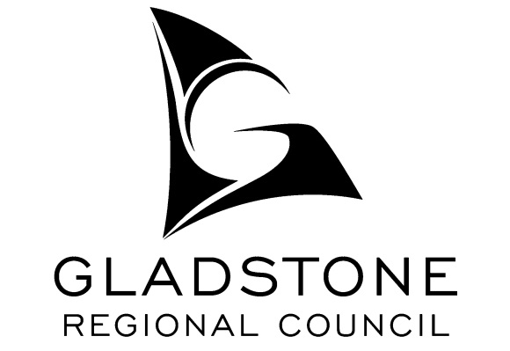
Submit online or hard copy.

Contact:
RADF Liaison Officer, Di Paddick
Gladstone Regional Art Gallery & Museum
Cnr Goondoon & Bramston Sts, Gladstone Q 4680
PO Box 29, Gladstone, Q 4680
Open: 10am - 5pm Monday to Saturday, public holidays as advertised
Phone: 4976 6766 Email: gragm@gladstone.qld.gov.au
Websites: http://www.gladstone.qld.gov.au
http://gragm.qld.gov.au/radf

